Experiment no : 05

Experiment name : Write a MATLAB program to perform QAM modulation and Demodulation

Objective :

Objective is to learn about of Quardrature Amplitude Modulation (QAM) and Demodulation .

Code :

clc;

close all;

clear all;

m1=input('amplitude of m1 :');

m2=input('amplitude of m2 :');

fm1=input('frequency of m1 :');

fm2=input('frequency of m1 :');

fc=input('frequency of carrier :');

t=0:.001:1

ms1=m1*sin(2*pi*fm1*t);

subplot(6,2,1);

plot(t,ms1,'b');

ms2=m2*sin(2*pi*fm2*t);

subplot(6,2,2);

plot(t,ms2,'b');

c1=cos(2*pi*fc*t);

c2=sin(2*pi*fc*t);

qam=(ms1.*c1)+(ms2.*c2); %modulated signal

subplot(6,2,3);

plot(t,qam,'r');

noise=sin(2*pi*t);

noise=noise+0.5*randn(size(t));

nms=noise+qam;

subplot(6,2,4);

plot(t,nms,'g');

ws = 50;

b = (1/ws)*ones(1,ws);

a = 1;

nms2=2*nms.*c1; % demodulated m1 msg signal

vout=filter(b,a,nms2);

subplot(6,2,5);

plot(t,vout,'r');

nms1=2*nms.*c2; %demodulated m2 msg signal

vout1=filter(b,a,nms1);

subplot(6,2,6);

plot(t,vout1,'r');

Output :

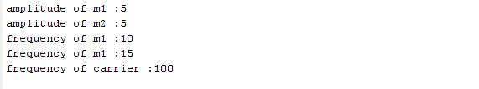

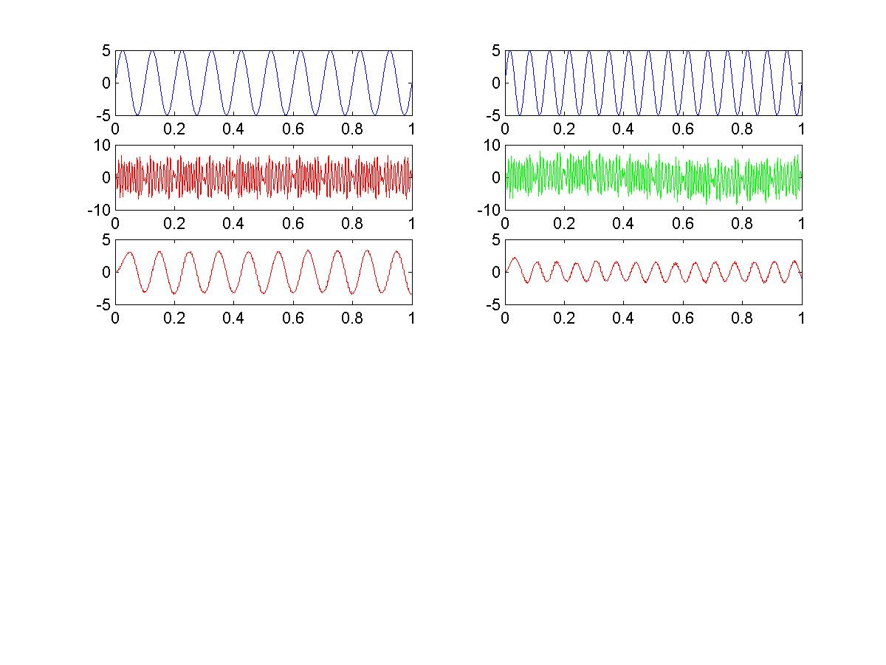

**Discussion :**

In this lab we learnt about Quadrature amplitude modulation (QAM) , which is both an analog and a digital modulation scheme. It conveys two analog message signals, or two digital bit streams . The two carrier waves of the same frequency, usually sinusoids, are out of phase with each other by 90° and are thus called quadrature carriers or quadrature components , hence the name of the scheme.